***Experiment 5 Output***

OLAP operations such as **slicing, dicing, drill-down, drill-up, and pivoting** were applied to analyze predefined data in a data warehouse.

***Creating Tables***

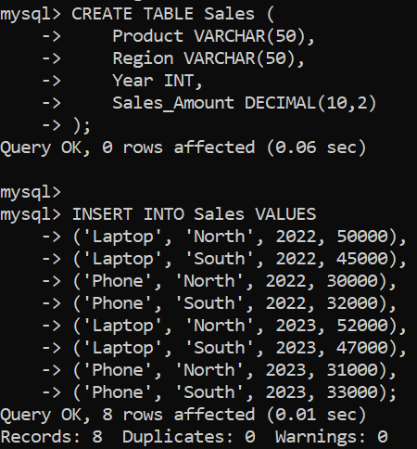

***Creating Database and Using in MySQL***

***Creating Tables***

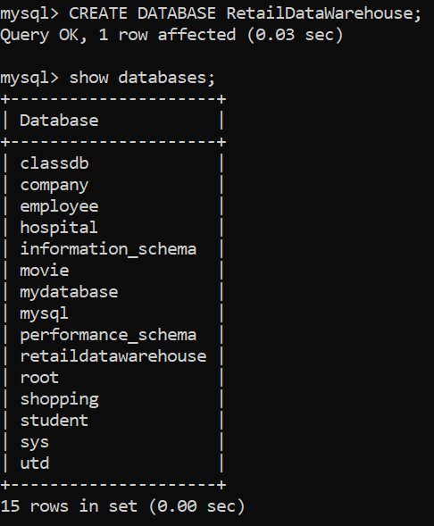

***Fig 2: Creating Tables and Inserting Data***

***Fig 1: Database in MySQL***

***OlAP operations***

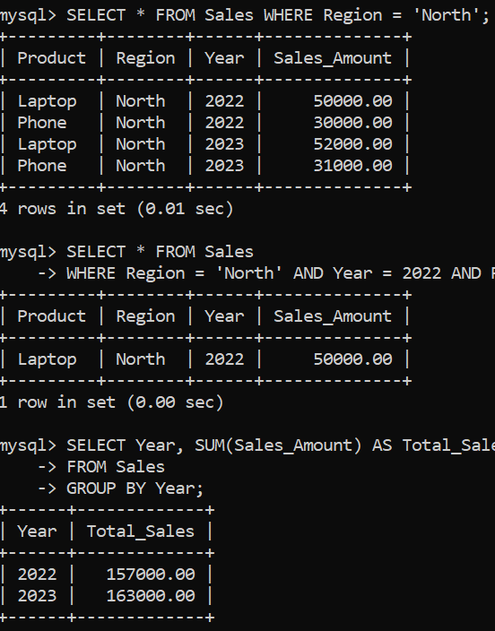

***Drill OLAP Operations***

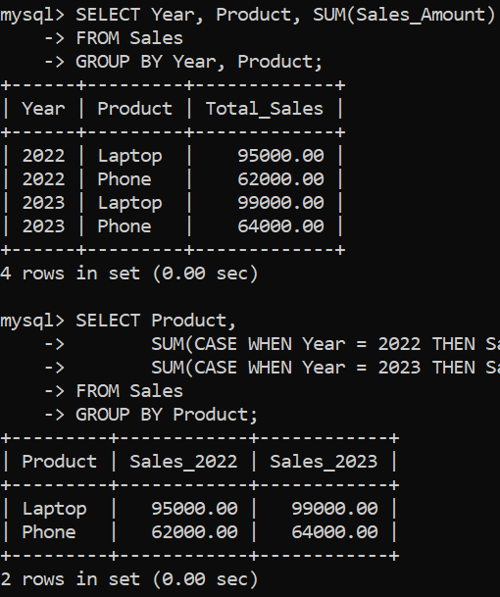

***Fig 3: Slicing and Dicing of Data***

***Fig 4: Drill up, down and pivoting***